Creating a Docker Account
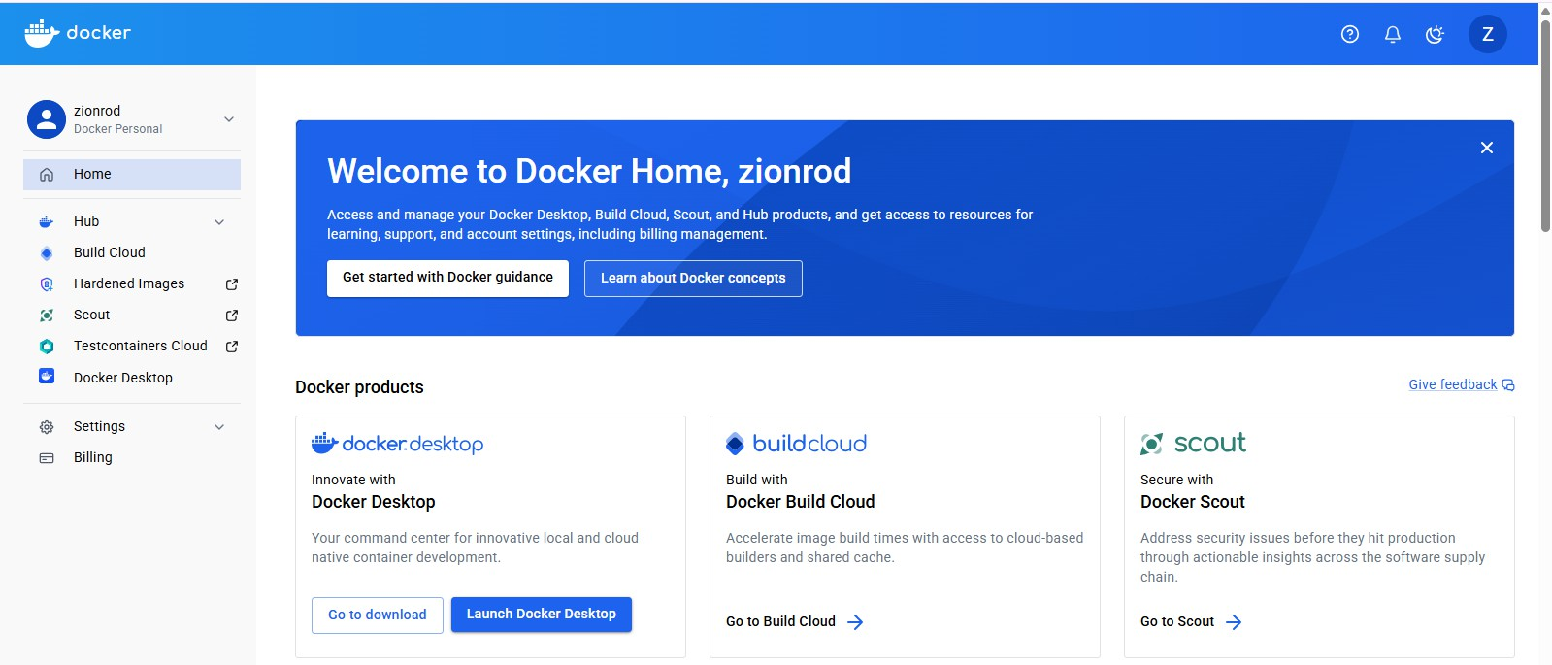
- docker version
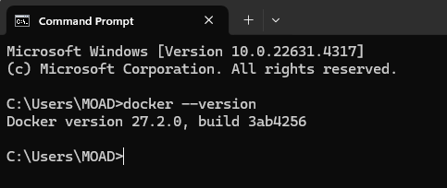
- docker login
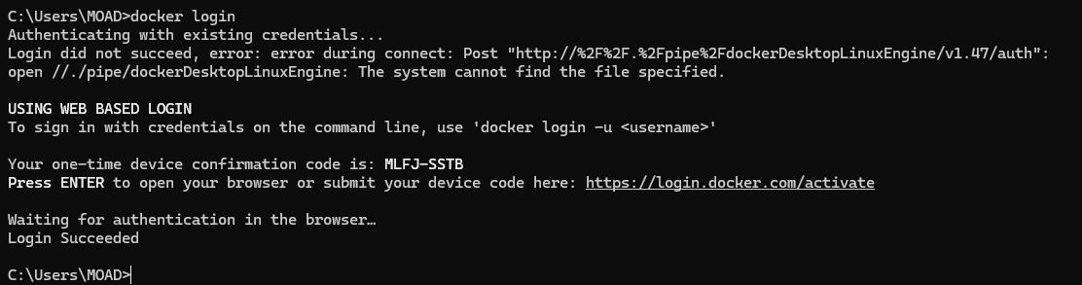
- docker images

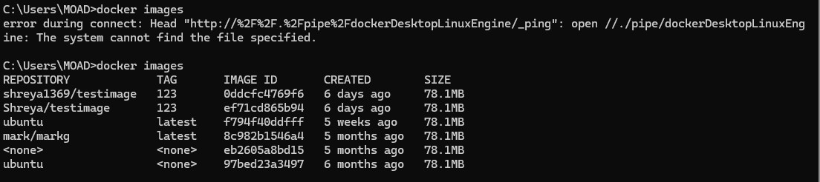
- docker pull image
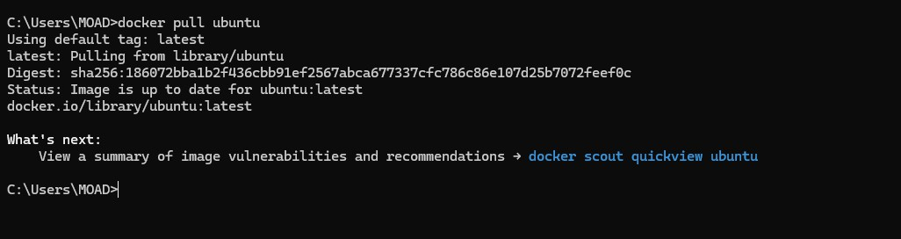
- docker images help
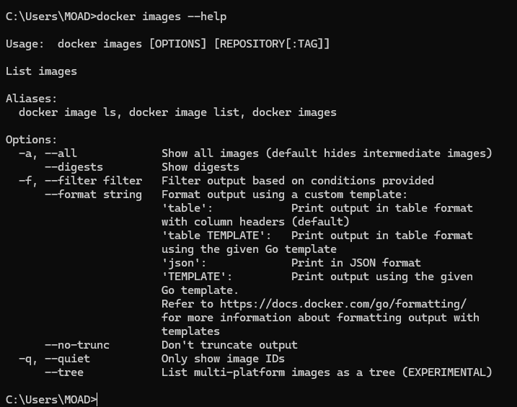

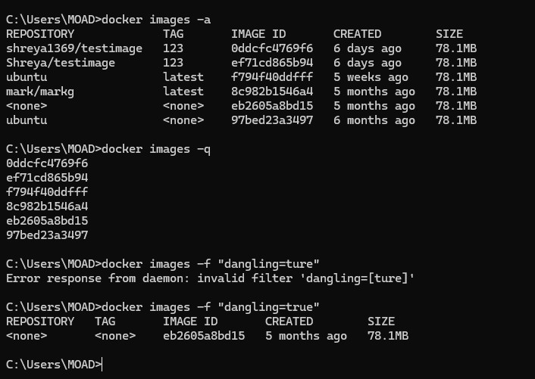
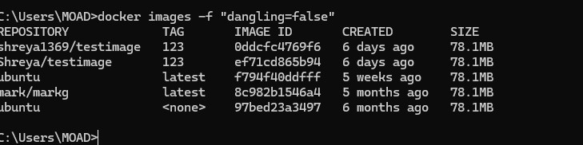
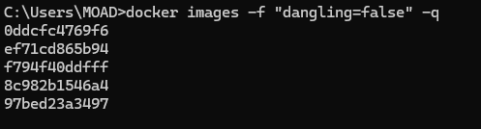

- Docker run commands
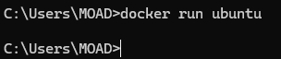
- docker ps

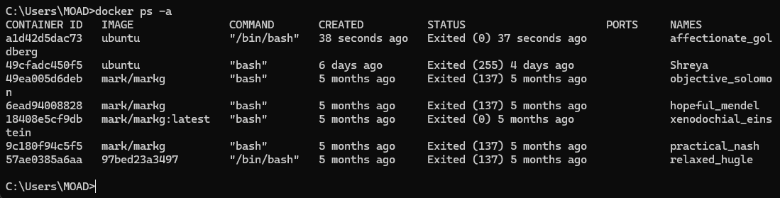
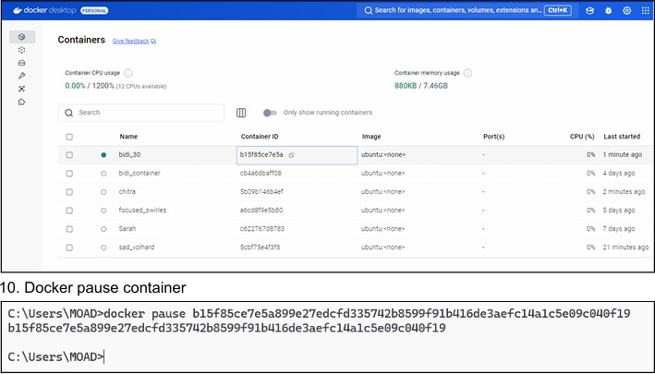

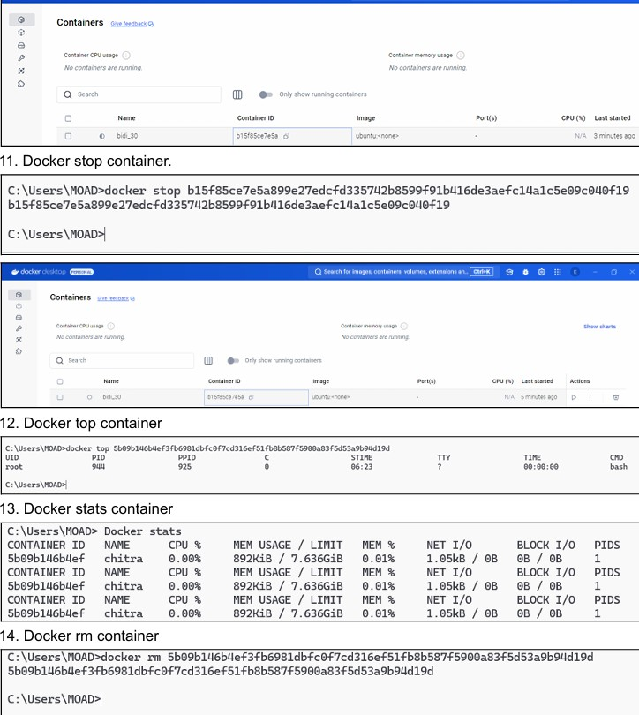

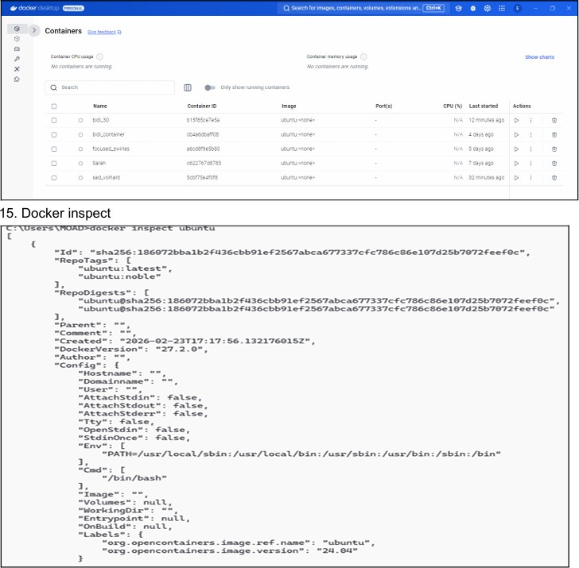

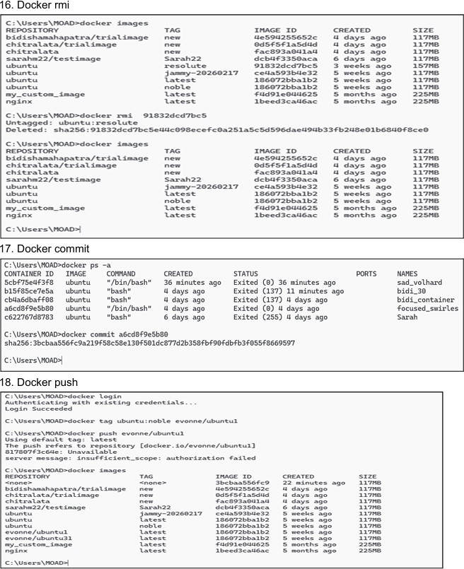

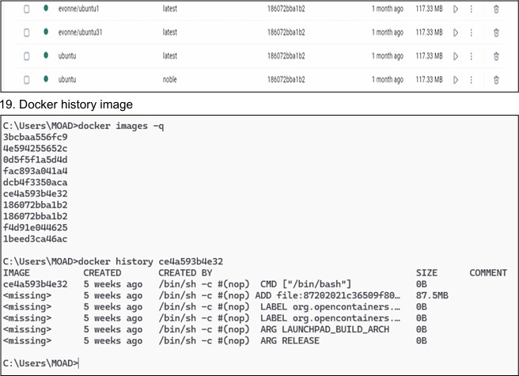

a. Answer the following:
  - What are Docker containers and Docker images?
    - Docker Image:
A Docker image is a read-only template used to create containers. It includes the application code, libraries, dependencies, and environment required to run an application.
    - Docker Container:
A Docker container is a running instance of a Docker image. It is lightweight, isolated, and portable, allowing applications to run consistently across different environments.
  - Explain Docker architecture with diagram
Docker Architecture consists of three main components:
- Docker Clien
  - User interface to interact with Docker
  - Runs commands like docker run, docker build
- Docker Host (Docker Engine)
  - Core system that manages containers
  - Includes:
- Docker Daemon
- Containers
- Images
- Docker Registry (Docker Hub)
  - Stores Docker images

  - Public or private repositories
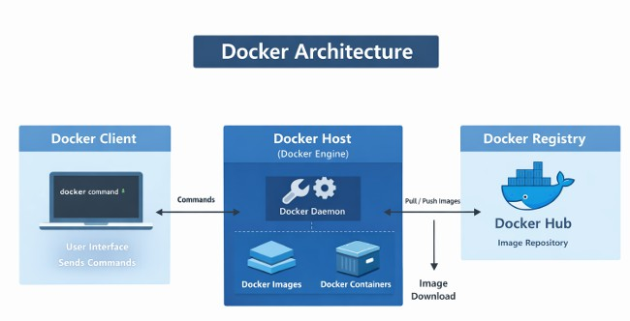
Working Flow: ● Client sends command → Docker Daemon executes → Pulls image from Docker Hub → Runs container.

